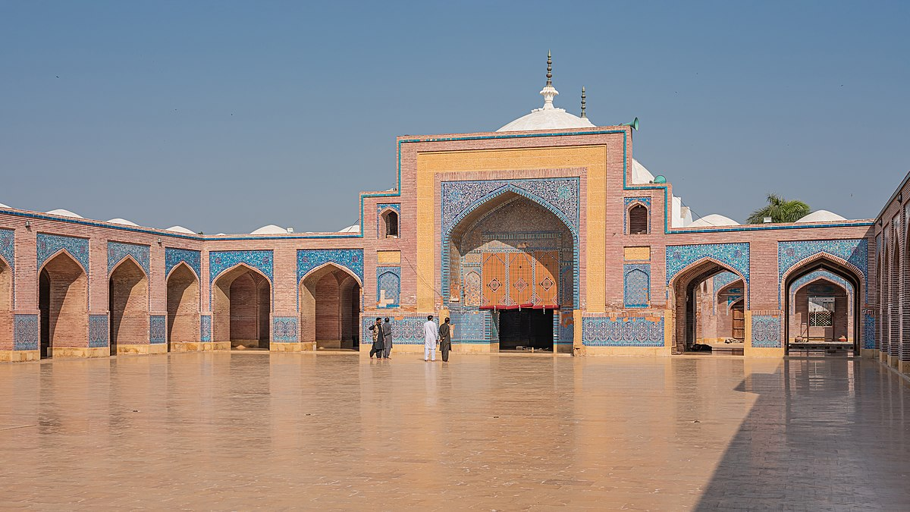

**SHAH-JAHAN-MOSQUE**

**Historical and Cultural Significance**

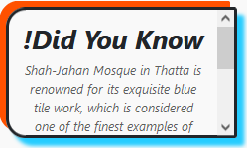The Shah-Jahan Mosque, located in Thatta, Sindh, Pakistan, is a magnificent testament to the grandeur of Mughal architecture and a significant cultural heritage site. Built during the reign of Emperor Shah Jahan in the 17th century, this mosque is renowned for its intricate tile work, which features beautiful floral patterns and vibrant blues that add to its serene and majestic appearance. The mosque's design exemplifies the classic Mughal style, with spacious courtyards, high domes, and expansive prayer halls. Its historical and architectural significance makes it a vital landmark for both historians and travelers who seek to understand the rich cultural tapestry of Pakistan’s Islamic heritage.

# Architectural Excellence and Beauty

The Shah-Jahan Mosque is a prime example of Mughal architecture,

combining both elegance and functionality. With its iconic blue tiles and

meticulously designed minarets, the mosque stands as a true masterpiece of Islamic art. Its symmetrical design and ornate calligraphy reflect the grandeur of the Mughal era, making it a prominent architectural jewel of Sindh. The mosque was designed by a local architect under the patronage of Shah Jahan, which is why it carries his name. Visitors are often in awe of the mosque's stunning craftsmanship, the brilliant use of colored tiles, and its distinctive blend of Persian, Turkish, and Mughal styles, each contributing to the mosque’s artistic richness.

**A Spiritual and Peaceful Retreat**

Beyond its architectural beauty, the Shah-Jahan Mosque holds profound spiritual significance. As a place of worship and reflection, it continues to serve as a center for prayer and community gatherings. The mosque's tranquil environment invites visitors to pause and reflect, offering them an escape from the hustle and bustle of everyday life. Its peaceful atmosphere, complemented by the beauty of its surroundings, makes it an ideal destination for spiritual contemplation. The mosque stands as a reminder of the timeless connection between faith and culture, where the peaceful rituals of prayer blend seamlessly with the magnificent architectural setting.

**Preserving a Legacy for Future Generations**

The Shah-Jahan Mosque is not just a historical monument but also a living piece of Pakistan’s cultural heritage. It has stood the test of time, enduring centuries of history, and continues to be an important site for both religious and cultural activities. As a UNESCO-listed site, the mosque is a symbol of Pakistan's rich Islamic legacy, drawing scholars, tourists, and pilgrims alike. Efforts to preserve and restore this architectural gem ensure that future generations will continue to appreciate its beauty and historical value. The Shah-Jahan Mosque stands as a beacon of the country's cultural and religious identity, inviting visitors to explore the depths of its heritage.

***ENJOYABLE ACTIVITIES***

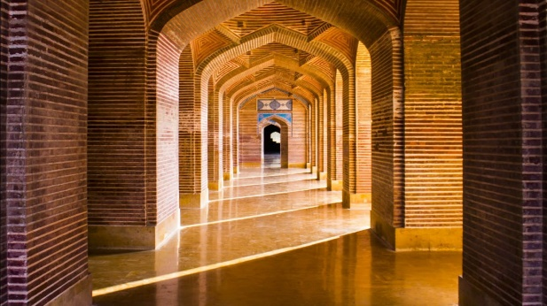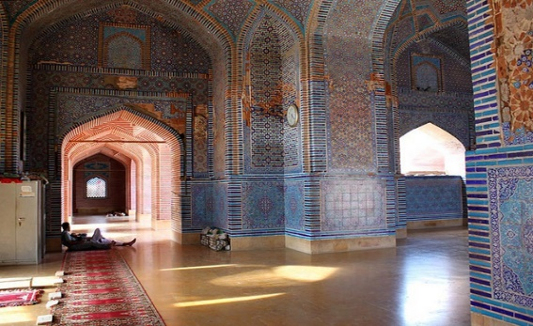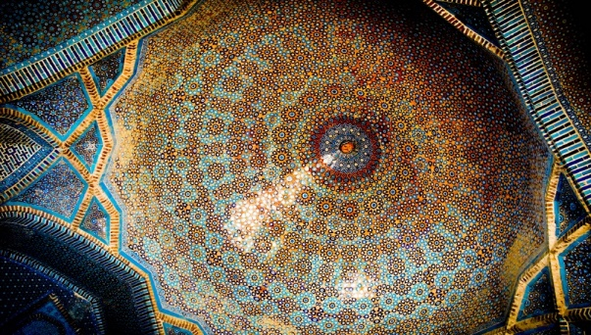

***! SHAH-JAHAN-MOSQUE TOP DESIGN TELL THE BEAUTI OF SHAH-JAHAN-MOSQUE***

***! SHAH-JAHAN-MOSQUE THE BEAUTI OF ENTRENCE IN SUN LIGHT***

***! SHAH-JAHAN-MOSQUE PLACE WHERE PEOPLE PRAY NAMAZ***

**The Shah-Jahan Mosque: A Masterpiece of Mughal Architecture**

The Shah-Jahan Mosque, located in Thatta, Sindh, Pakistan, is one of the most exquisite examples of Mughal architecture in the region. Commissioned by Emperor Shah Jahan in the 17th century, this mosque is a stunning representation of Islamic art, blending Persian, Turkish, and Mughal styles into a harmonious design. The mosque’s most remarkable feature is its intricate tile work, which adorns the walls and domes in a dazzling array of geometric patterns and vibrant colors, particularly shades of blue, green, and gold. The spacious prayer halls, soaring domes, and delicate minarets all contribute to the mosque’s grandeur, making it a must-visit for both pilgrims and tourists alike. The Shah-Jahan Mosque’s historical importance, architectural splendor, and cultural significance make it a symbol of the enduring legacy of the Mughal Empire, reflecting the era’s devotion to craftsmanship, beauty, and spiritual devotion.

**The Shah-Jahan Mosque: A Testament to Islamic Heritage**

The Shah-Jahan Mosque in Thatta stands as an enduring testament to the rich Islamic heritage of the subcontinent. Built in the early 1600s, the mosque reflects the grandeur of the Mughal dynasty and is known for its breathtaking tile work and intricate architectural details. Its design emphasizes symmetry, with large prayer halls, majestic domes, and towering minarets that create a harmonious and inviting space for worshippers. The mosque’s walls are adorned with exquisite blue and white tiles, many featuring intricate floral and geometric patterns, which were crafted using advanced techniques of the time. These beautiful tiles, combined with the mosque's serene atmosphere, make it not just a place of prayer, but also a work of art. Today, the Shah-Jahan Mosque stands as an iconic symbol of Pakistan’s cultural and religious identity, drawing visitors from around the world who come to admire its beauty and reflect on its historical significance.

**LOCATION**

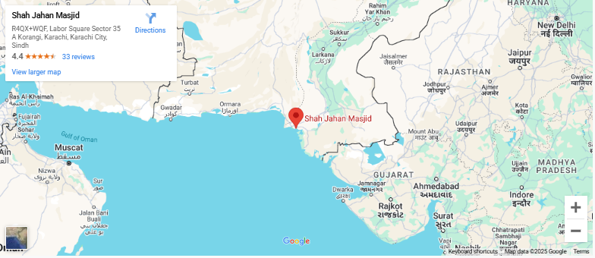

The Shah Jahan Mosque is located in Thatta, a city in the Sindh province of Pakistan. It is known for its beautiful architecture and historical significance.

**Why Visit Shah-Jahan-Mosque?**

**Visiting the Shah-Jahan Mosque offers a chance to witness stunning Mughal architecture and intricate tile work, making it a visual feast for history and art enthusiasts. The serene atmosphere provides a peaceful space for reflection and spiritual connection.**

**FEATURED PRODUCT**